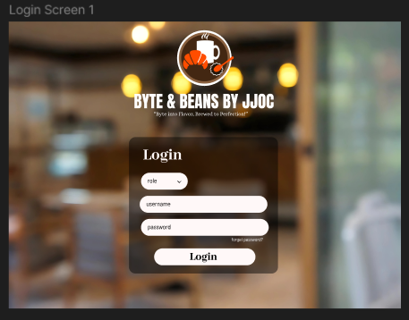

Login Screen

The first screen welcomes users with a clean login form where they can enter their username and password and also their role.

A simple "Login" button lets users access the system.

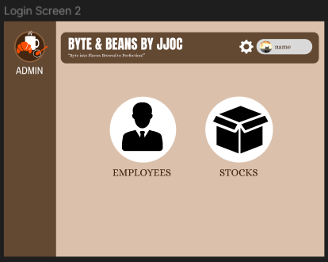

Admin Dashboard

Once logged in as an Admin, users see a main menu with two options: Employees and Stocks.

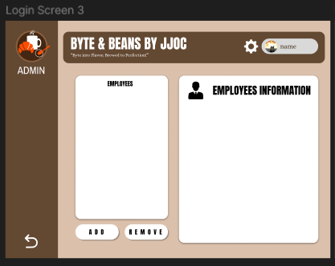

Employee Management

This screen helps the admin manage employees, showing a list of registered employees on the left.

On the right, there's an information panel to display details about a selected employee.

Buttons like "Add" and "Remove" allow easy employee management.

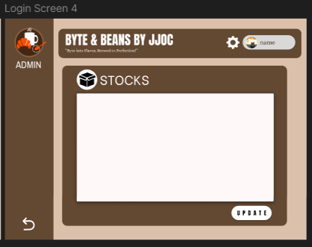

Stock Management

A straightforward page for tracking and updating inventory.

A large section is reserved for listing stock details, and an "Update" button ensures admins can modify stock records when needed.

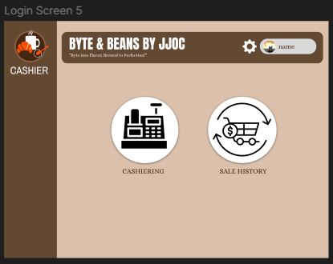

Cashier Dashboard

When logged in as a Cashier, the home screen presents two options:

* Cashiering – to process customer orders.
* Sales History – to review past transactions.

The layout is clear, making it easy for cashiers to navigate.

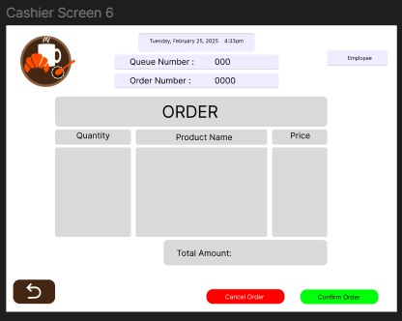

Order Processing

This screen is where cashiers enter customer orders.

It includes fields for product quantity, name, and price, along with a total amount display.

Buttons for "Cancel Order" and "Confirm Order" help manage transactions efficiently.

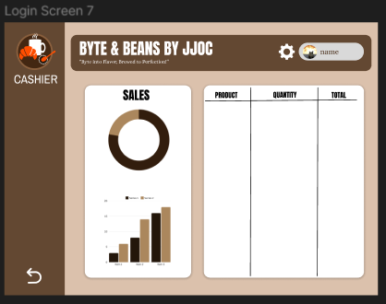

Sales Overview

A visual breakdown of sales, combining charts and tables for a quick summary.

The left side has a pie chart and bar graph for sales trends, while the right lists products, quantities, and total sales.